Multimodal Product Knowledge RAG: AI-Powered Product Support Assistant - RAG - Gemini 2.8 flash

Project Description
Multimodal Product Knowledge RAG uses Retrieval-Augmented Generation (RAG) and multimodal AI to let users get product information from both text and images. The platform has these modules:
- A Product Image Analysis module, which identifies product type, model details, labels and error codes from an uploaded image.
- A Document Processing module, which ingests manuals, specifications, FAQs and troubleshooting guides.
- A RAG Retrieval module, which finds the most relevant document sections for a question.
- A Troubleshooting module, which returns step-by-step fixes.
- A Citation module, which shows the sources behind every answer.
The system uses OCR to extract text from images and scanned documents. It converts the content into embeddings with Sentence Transformers and stores them in a vector database (FAISS / ChromaDB). It then passes the retrieved context to a multimodal Large Language Model to generate grounded answers. It is built with Flask and a single-page web interface, and it uses a modular blueprint-based REST API (/api/v1/...). This helps customers, support teams and technicians find product features, specifications, error resolutions and maintenance procedures without searching through lengthy documents.

Scenarios
Scenario 1: A user uploads a photo of a washing machine display showing an error code. The Product Image Analysis and OCR modules read the product type, model label and error code. The RAG module retrieves the matching section of the troubleshooting guide, and the system returns step-by-step fix instructions with the manual name and page reference.
Scenario 2: A user asks, "What is the warranty period and battery capacity of this model?" The system searches the vector database across the specifications sheet and FAQs, and generates a concise, context-aware answer with citations to the source documents.
Scenario 3: A support administrator uploads a new product manual and a set of FAQs. The Document Processing module extracts and chunks the text (using OCR for scanned pages), creates embeddings and adds them to the knowledge base. The new content is immediately available for queries and follow-up questions in the chat interface.

Technical Architecture

Description
The system uses a modular multi-tier architecture. The frontend is a Single Page Application (SPA) built with HTML, CSS and JavaScript. It is served by a Flask backend at the root route (/) and talks to the server through JSON APIs. The backend is created with a Flask application factory (create_app) and organised into five API blueprints, each with its own URL prefix:
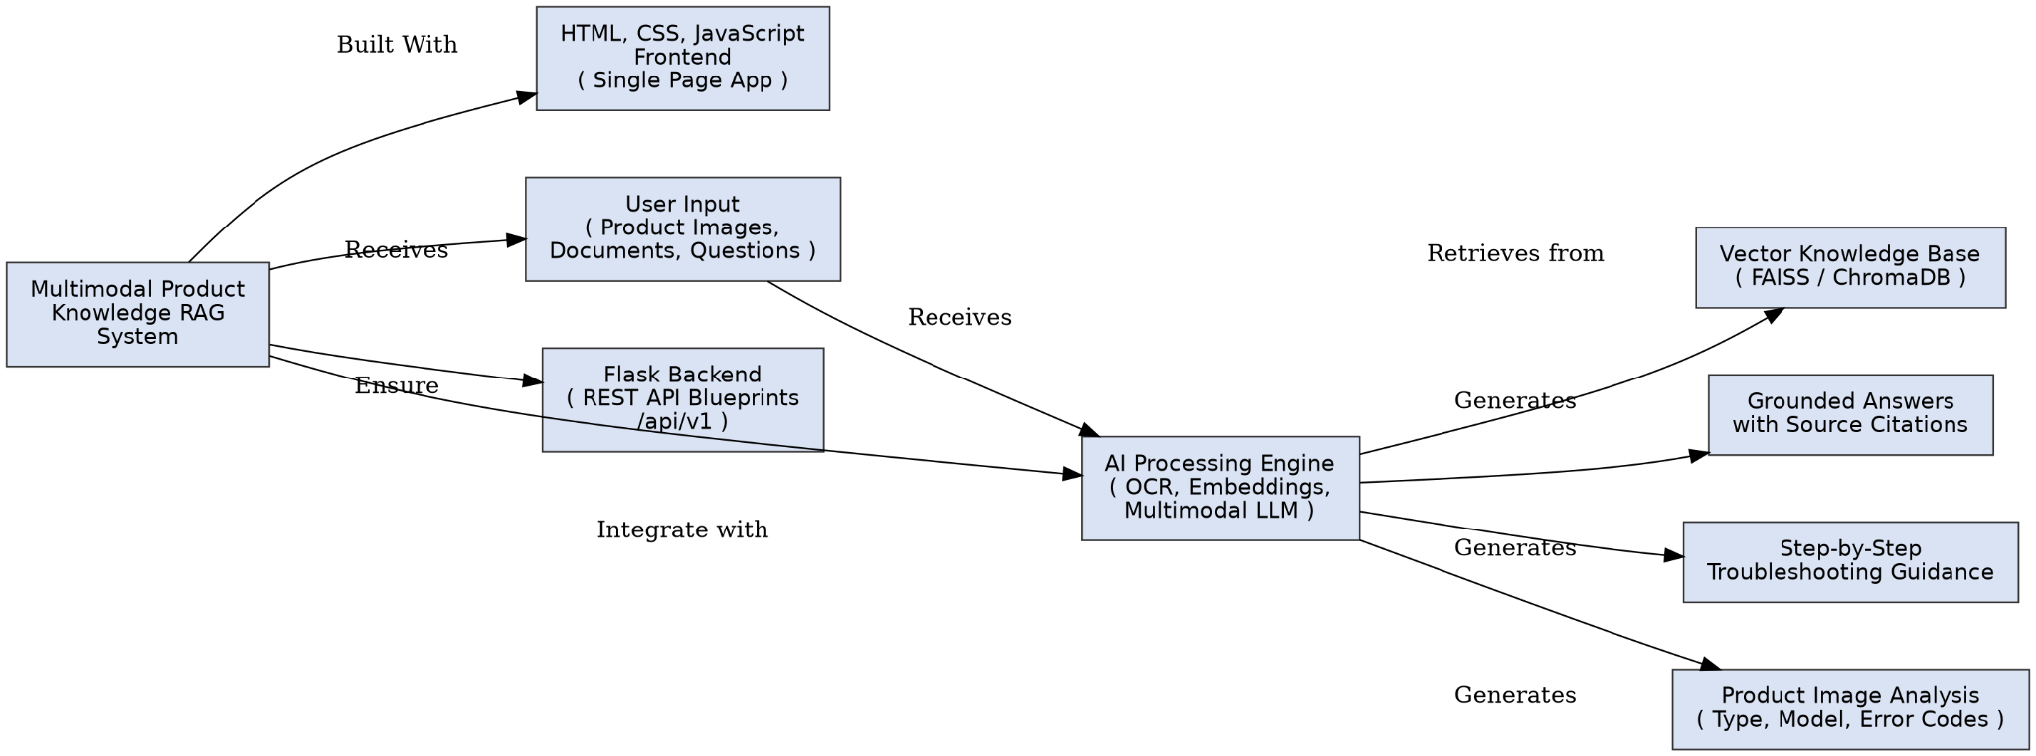
Processed content is converted to embeddings and stored in a vector database. At query time the RAG layer retrieves the top matching chunks, and a multimodal LLM generates a grounded answer with source citations. Global JSON error handlers (404 and 500) keep error responses consistent.

ER Diagram
This project uses a vector database (FAISS / ChromaDB) rather than a relational database, so the "ER diagram" is replaced by a description of the knowledge-base structure. Each stored record consists of:
- an embedding vector
- the text chunk
- metadata: source document name, section or page number, product name or model, and content type (manual, specification, FAQ, troubleshooting or image-derived text)
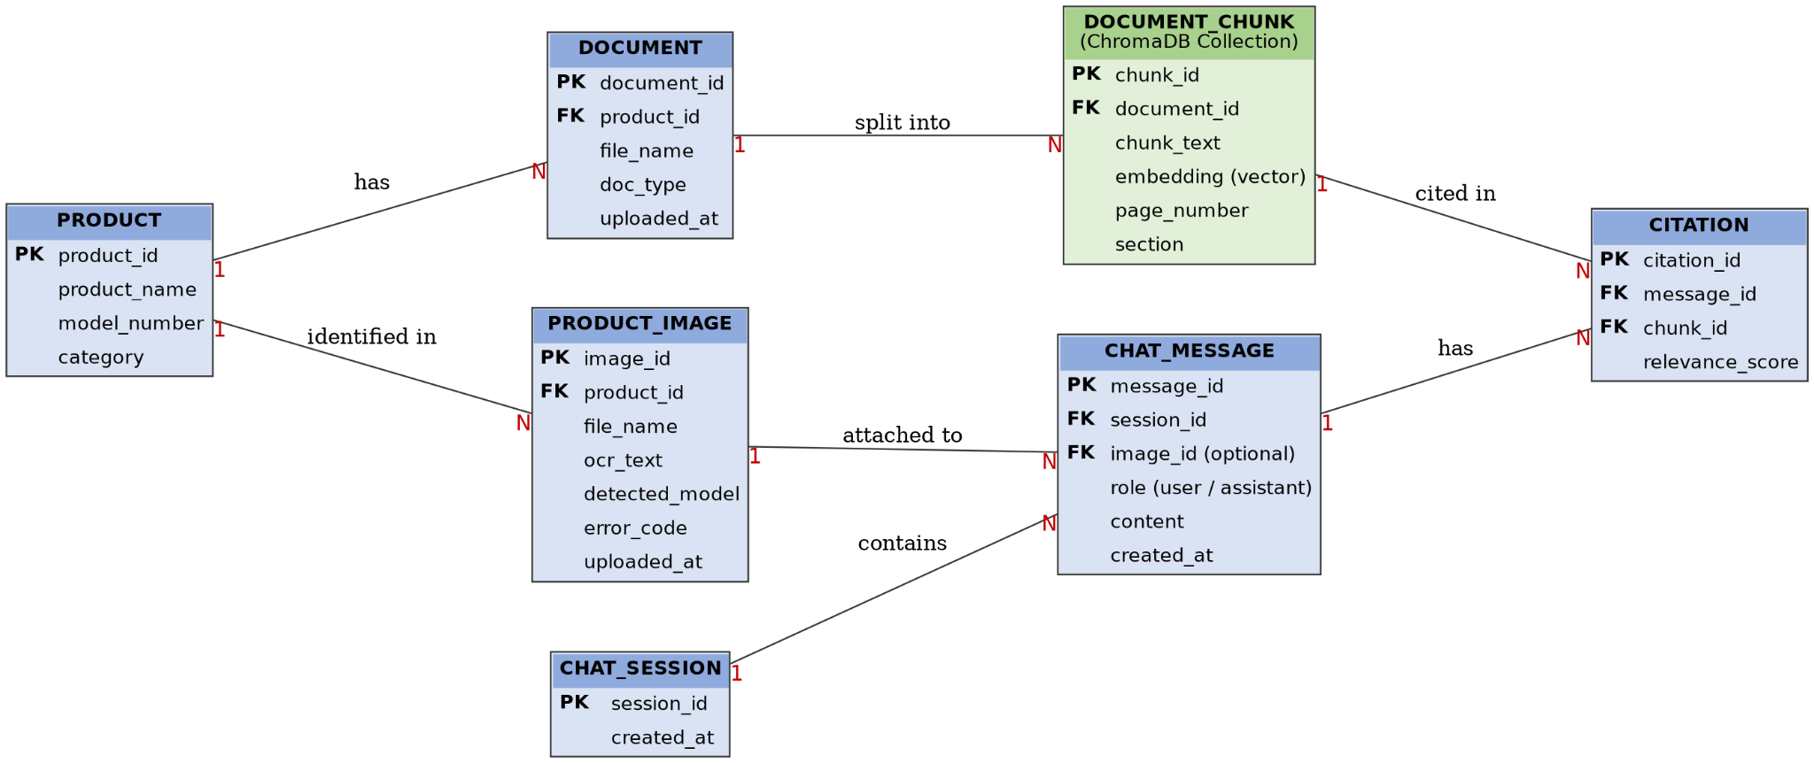

Pre-requisites
- Flask Framework Knowledge: https://flask.palletsprojects.com/en/stable/tutorial/
- Flask Blueprints Knowledge: https://flask.palletsprojects.com/en/stable/blueprints/
- Python Programming Proficiency: https://docs.python.org/3/
- HTML, CSS and JavaScript Skills: https://www.w3schools.com/
- Understanding of RAG and Embeddings: https://www.sbert.net/
- Vector Database Familiarity (FAISS): https://faiss.ai/ or (ChromaDB): https://docs.trychroma.com/
- OCR Familiarity (Tesseract): https://github.com/tesseract-ocr/tesseract or (EasyOCR): https://github.com/JaidedAI/EasyOCR
- Multimodal LLM API Familiarity (your chosen provider's documentation)
- Version Control with Git: https://git-scm.com/docs/git
- Development Environment Setup: https://flask.palletsprojects.com/en/stable/installation/

Project Workflow
Milestone 1: Model Selection and Architecture
- Activity 1.1: Obtain the multimodal LLM API key and configure it securely in the project environment.
- Activity 1.2: Research and select the multimodal LLM, OCR engine, embedding model and vector database.
- Activity 1.3: Define the application architecture, detailing the frontend, Flask blueprints, vector store and AI integration.
- Activity 1.4: Set up the development environment, installing the necessary libraries and dependencies.
Milestone 2: Core Functionalities Development
- Activity 2.1: Develop the Product Image Analysis, OCR Processing and Document Processing modules.
- Activity 2.2: Develop the Embedding and Vector Database, RAG Retrieval, AI Response Generation, Troubleshooting and Citation modules.
Milestone 3: App.py and API Development
- Activity 3.1: Write the main application logic in app.py, creating the Flask app factory and registering all API blueprints.
- Activity 3.2: Implement the blueprint routes and the global error handlers.
Milestone 4: Frontend Development
- Activity 4.1: Design and develop the single-page interface using HTML, CSS and JavaScript.
- Activity 4.2: Implement dynamic rendering of chat responses, citations and troubleshooting steps using JavaScript.
Milestone 5: Deployment
- Activity 5.1: Prepare the application for local deployment.
- Activity 5.2: Run and verify the application locally.
Milestone 6: Conclusion

Milestone 1: Model Selection and Architecture
In this milestone, we select the AI components for the system: the multimodal LLM, the OCR engine, the embedding model and the vector database. We also define how the frontend, backend and AI pipeline interact.

Activity 1.1: Obtain the Multimodal LLM API Key
Before the application can generate answers, you need a valid API key for your chosen multimodal LLM provider.
- Step 1: Create an account on your chosen provider's console.
- Step 2: Navigate to the "API Keys" section of the dashboard.
- Step 3: Click "Create API Key" and give it a descriptive name (e.g., product-rag-key).
- Step 4: Copy the key immediately and store it safely. It cannot be viewed again after the dialog is closed.
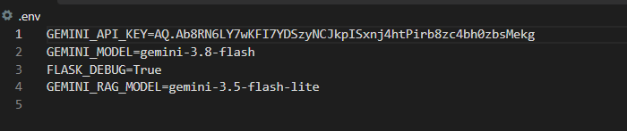
- Step 5: Create a .env file in the project root and add the key:

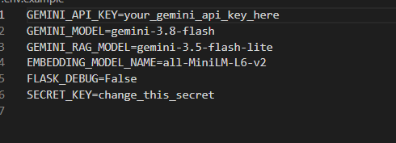
- Step 6: Verify the configuration is loaded. The app reads its settings through config.py (config.SECRET_KEY, config.MAX_CONTENT_LENGTH, config.DEBUG), which loads the values from the environment at startup:

- Important: never commit your API key. Add .env to your .gitignore file:

Activity 1.2: Research and Select the AI Components
- Understand the Project Requirements: Review the needs of the system. It must analyze product images, read text from images, process documents, retrieve relevant content and generate grounded answers with citations.
- Select the Multimodal LLM: Choose a multimodal Large Language Model that can understand both images and text, and generate accurate, context-aware responses.
- Select the OCR Engine: Choose Tesseract or EasyOCR to extract text from product images, labels and scanned documents.
- Select the Embedding Model: Use Sentence Transformers to convert text chunks into embeddings for semantic similarity search.
- Select the Vector Database: Choose FAISS or ChromaDB to store embeddings and perform fast similarity search.

Activity 1.3: Define the Architecture of the Application
- Draft an Architectural Diagram: Create a visual representation of the frontend (HTML, CSS, JavaScript), the Flask backend with its five blueprints, the OCR and embedding pipeline, the vector database and the multimodal LLM.
- Detail Frontend Functionality: Outline how users upload product images, upload documents, ask questions in the chat interface, and view answers with citations and troubleshooting steps.
- Outline Backend Responsibilities: Specify how the Flask backend receives requests through the versioned API (/api/v1/...), validates uploads, and enforces the upload size limit (MAX_CONTENT_LENGTH).
- Describe AI Integration Points: Define the pipeline. An image or document is processed with OCR, chunked, embedded and stored. A user query is embedded and searched against the vector database. The top results are passed to the multimodal LLM, which generates the final answer with sources.

Activity 1.4: Set Up the Development Environment
- Install Python and Pip: Ensure Python 3.8+ is installed along with pip.
- Create a Virtual Environment:
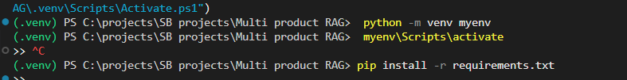
- Install Flask:
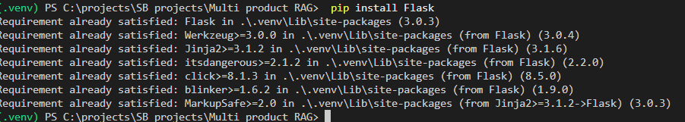
- Install python-dotenv (secure key management):
- Install the OCR, Embedding and Vector Database libraries:
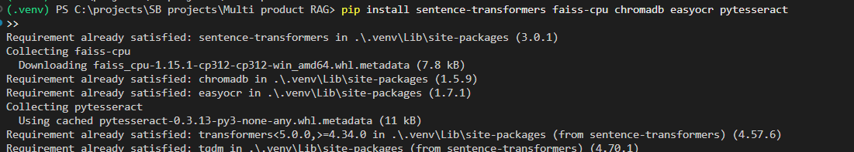
(Install only the OCR engine and vector database you selected in Activity 1.2. Tesseract also requires the Tesseract executable to be installed on your machine.)
- Configure the Environment: Create the .env file in the project root as shown in Activity 1.1.
- Set Up the Application Structure: Create the project directory structure:
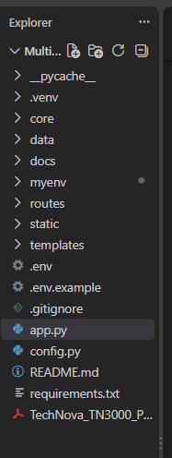

Milestone 2: Core Functionalities Development

Activity 2.1: Develop the Ingestion Modules
- Product Image Analysis Module: Analyzes uploaded product images using multimodal AI to identify the product type, visible model details, labels and error codes.
- OCR Processing Module: Extracts text from product images, labels, manuals and other image-based documents so the content becomes searchable.
- Document Processing Module: Processes product manuals, specifications, FAQs and troubleshooting documents, splits them into chunks and prepares them for knowledge retrieval.

Activity 2.2: Develop the Retrieval and Response Modules
- Embedding and Vector Database Module: Converts processed content into embeddings and stores them, with metadata, in the vector database for semantic similarity search.
- RAG Retrieval Module: Understands the user's question, searches the vector database and retrieves the most relevant document sections.
- AI Response Generation Module: Sends the retrieved context, and the image where relevant, to the multimodal LLM to generate contextual, grounded answers.
- Troubleshooting Module: Produces step-by-step instructions based on the relevant manuals and technical documentation.
- Citation and Source Module: Returns the document names, sections or page references used to build the answer, for transparency and traceability.
- Product Knowledge Chat Module: Supports follow-up questions through a conversational interface.

Milestone 3: App.py and API Development
Milestone 3 focuses on the app.py file, the entry point of the application. It creates the Flask app, applies the configuration, registers the API blueprints and defines the main route and error handlers.

Activity 3.1: Writing the Main Application Logic in app.py
Create the Flask Application Factory:
- The create_app() function builds the Flask app with its static and template folders, and applies the SECRET_KEY and MAX_CONTENT_LENGTH values from config.py.
python
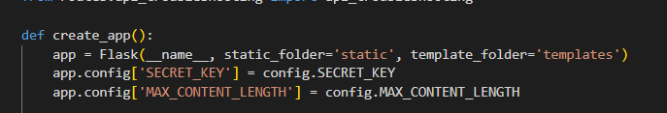
Register the API Blueprints:
- Each feature area is a separate blueprint with its own URL prefix:
python
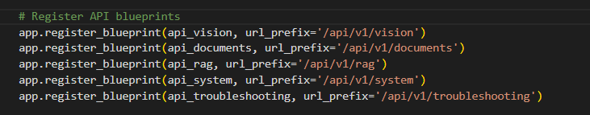
- /api/v1/vision: image analysis and OCR of uploaded product images
- /api/v1/documents: upload and processing of manuals, specifications, FAQs and troubleshooting documents
- /api/v1/rag: question answering with retrieval, generation and citations
- /api/v1/system: system and status information
- /api/v1/troubleshooting: step-by-step troubleshooting guidance
Define the Main SPA Route:
- / is the home route that renders index.html, the single-page interface.
python
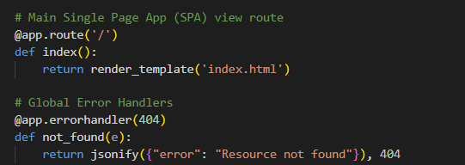
Define the Global Error Handlers:
- Return consistent JSON errors for missing resources and server failures.
python
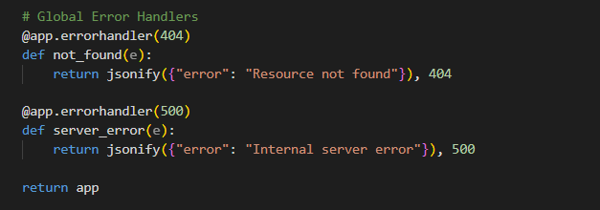
Run the Server:
- The app reads the port from the PORT environment variable (default 5000), listens on all interfaces and uses config.DEBUG for debug mode.
python
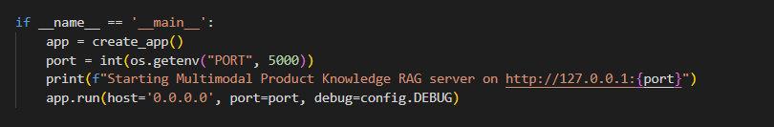
Route Summary:
- / (GET): renders index.html
- /api/v1/vision/*: image analysis and OCR endpoints
- /api/v1/documents/*: document ingestion endpoints
- /api/v1/rag/*: retrieval and answer generation endpoints
- /api/v1/troubleshooting/*: troubleshooting endpoints
- /api/v1/system/*: system endpoints

Activity 3.2: Implement the Blueprint Routes
- Read the uploaded files or JSON body of each request using Flask's request object.
- Validate inputs, for example allowed file types, missing files and empty questions, and return clear 400 errors.
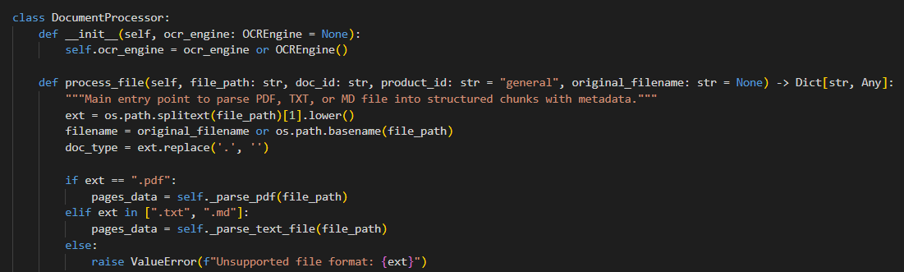
- Call the corresponding module (OCR, embeddings, retrieval or LLM) and return a structured JSON response containing the answer, the citations and any troubleshooting steps.
- Wrap the AI calls in try/except blocks so failures return clean JSON errors.
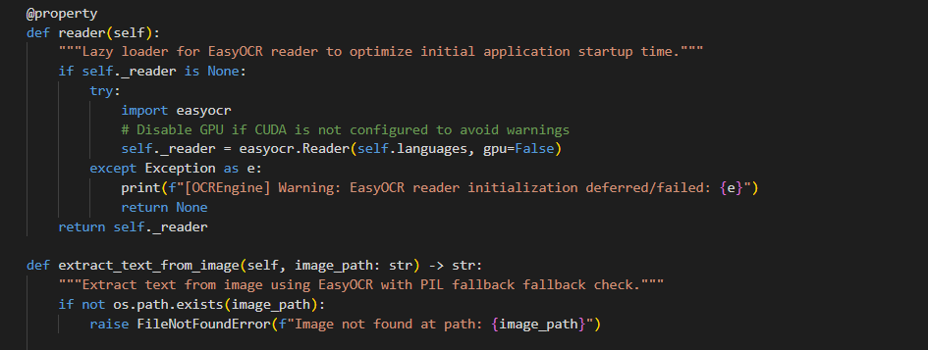

Milestone 4: Frontend Development
Milestone 4 focuses on a clean, responsive single-page interface. Users can upload images and documents, chat with the knowledge base and read answers together with their sources.

Activity 4.1: Designing and Developing the User Interface
Set Up the Base HTML Structure:
- Develop templates/index.html as the single-page interface, with a header showing the project name, an upload section, a chat section and a results and citations section.
- Use semantic HTML elements to keep the structure organised and accessible.
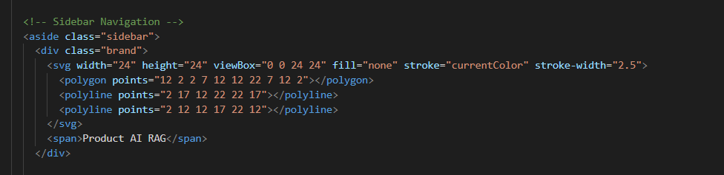
Design a Responsive Layout Using CSS:
- Create stylesheets in static/css/ using flexbox and grid to organise the upload panel, chat panel and citation panel.
- Add media queries so the layout adapts to desktop, tablet and mobile screens.
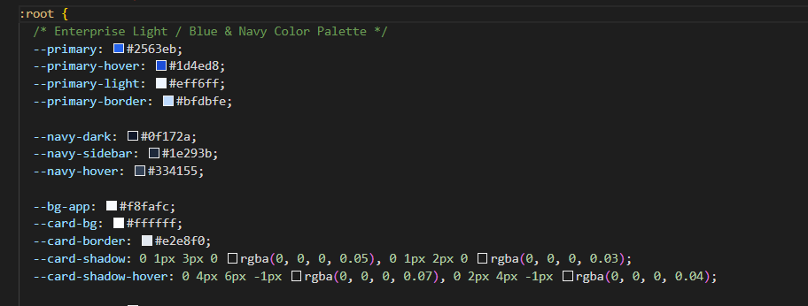

Create Separate UI Components:
- Image Upload Panel: lets users upload a product image and see a preview along with the detected product details and error codes.
- Document Upload Panel: lets administrators upload manuals, specifications, FAQs and troubleshooting documents.
- Chat Interface: a conversational area for questions and follow-up questions.
- Troubleshooting Steps View: displays the step-by-step instructions in a numbered list.
- Citation Cards: show the document name and section or page reference for each answer.
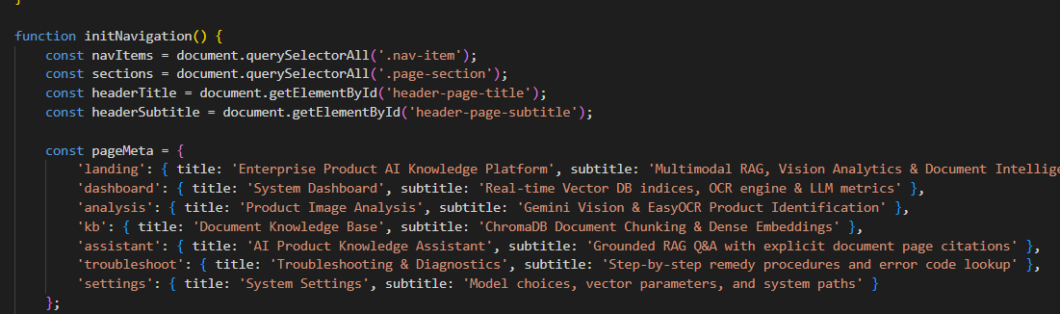

Activity 4.2: Creating Dynamic Content Rendering with JavaScript
Handle Requests Asynchronously:
- Use the Fetch API to send images, documents and questions to the /api/v1/... endpoints without reloading the page.
- Show a loading indicator and disable the submit buttons while a request is processed.
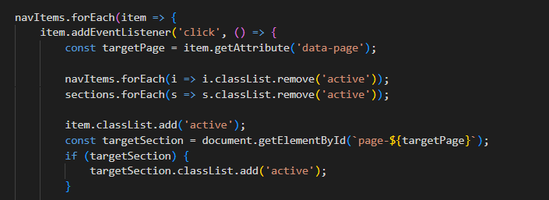

Render Results Dynamically:
- Create JavaScript functions that inject the answer, troubleshooting steps and citations into the page.
- Automatically scroll the chat view to the latest response.
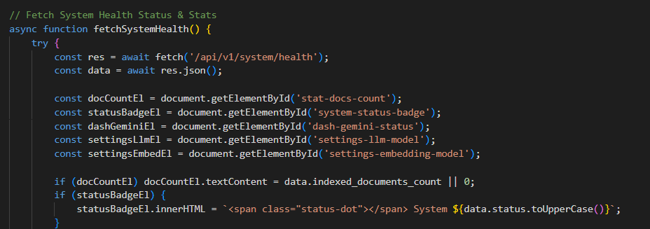
Restore UI State:
- In the finally block of each async handler, re-enable the buttons and hide the loader, whether the request succeeded or failed.
- Show a friendly message when the API returns an error.
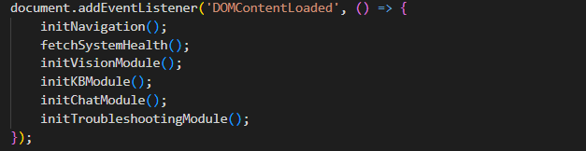

Milestone 5: Deployment
In Milestone 5, we deploy and verify the application locally, configuring the server environment and managing the dependencies.

Activity 5.1: Preparing the Application for Local Deployment
Set Up a Virtual Environment:
- Open a new terminal and then open "Command Prompt".
- Create and activate a virtual environment, then install all required dependencies:
Configure Environment Variables:
- Create a .env file in the project root with your API key and secret key. The optional PORT variable changes the server port (default 5000):

Activity 5.2: Local Testing and Verification
Start the Flask Development Server:
- Run the application: 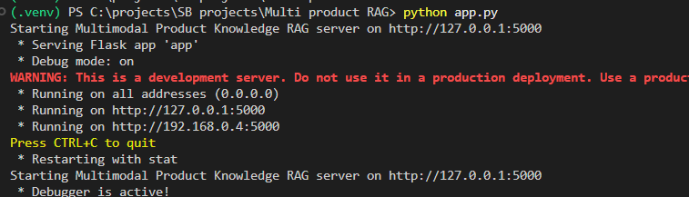
- The terminal prints: "Starting Multimodal Product Knowledge RAG server on http://127.0.0.1:5000". Open that address in a browser.
- Upload sample manuals, specifications and FAQs. Then upload a product image and ask questions to verify that:
  - the OCR extracts the text correctly
  - the retrieved content is relevant
  - the answers are grounded, with correct citations
  - the troubleshooting steps are clear and ordered
  - follow-up questions work in the chat
Important Notes:
- Set DEBUG to False in config.py for any shared or demo deployment.
- Keep the .env file private and out of version control.
- The upload size limit (MAX_CONTENT_LENGTH) rejects files larger than the configured value.

Exploring the Website's Web Pages

Home / Chat Page
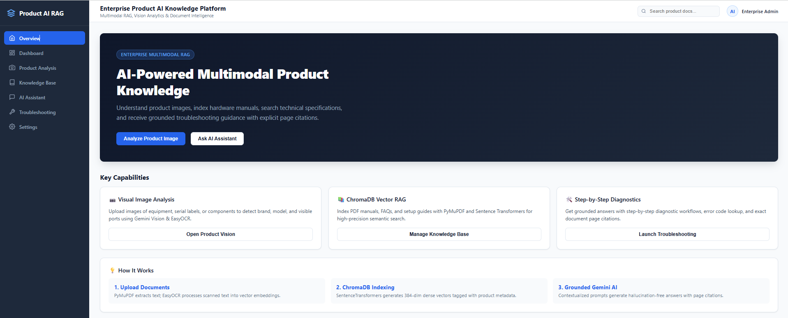
Description: The single-page interface serves as both the landing page and the working tool. It has a header with the project name, and a main area for uploading product images and documents, chatting with the knowledge base, and viewing answers and citations, all on one page.

Image Analysis Section
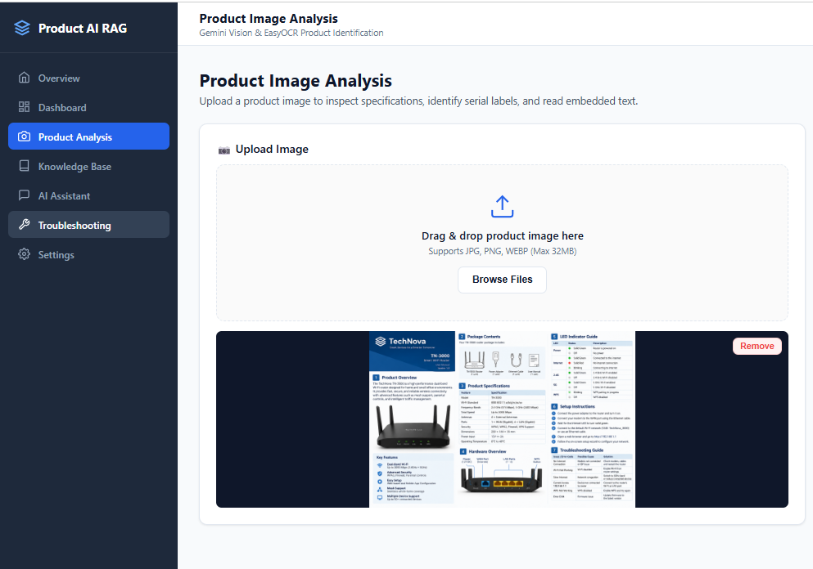
Description: Users upload a product image and the system shows the identified product type, visible model details, labels and error codes, with the text extracted using OCR. This information is used to search the knowledge base automatically.

Document Upload Section
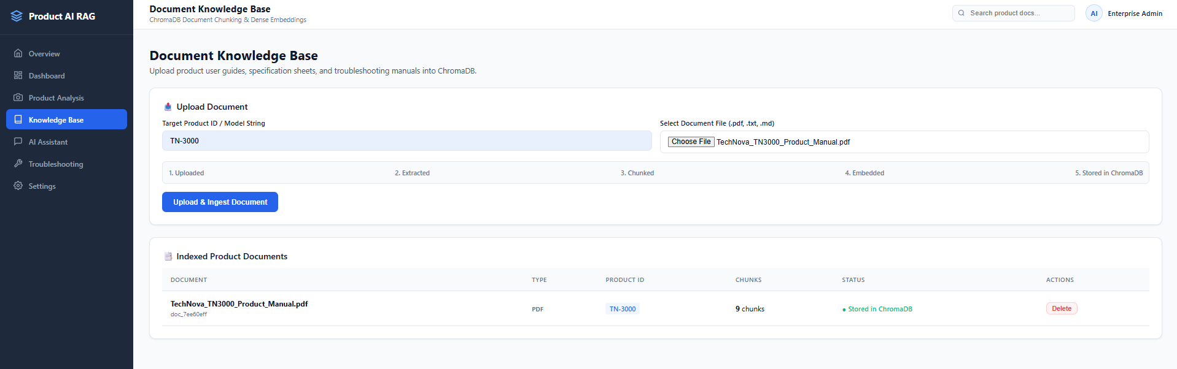
Description: Users upload product manuals, specifications, FAQs and troubleshooting documents. The system processes them (with OCR for scanned pages), creates embeddings and stores them in the vector database, making them available for questions immediately.

Chat and Troubleshooting Section
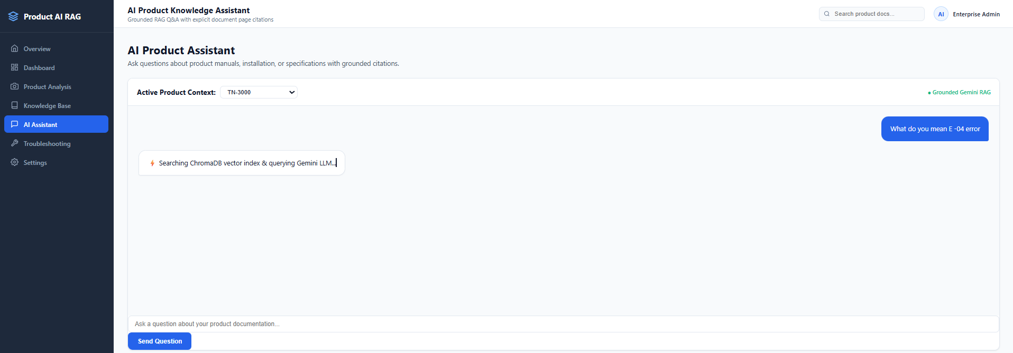

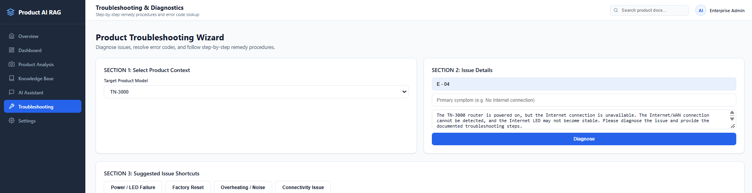
Description: Users ask questions and follow-up questions in a conversational interface. Each answer is grounded in the retrieved content, and for problems and error codes it includes step-by-step troubleshooting instructions.

Conclusion
The Multimodal Product Knowledge RAG system is a generative AI platform built with Flask that lets users find product information through both text and images. It combines OCR, multimodal image understanding, Sentence Transformer embeddings and a vector database (FAISS / ChromaDB) with Retrieval-Augmented Generation to give accurate, context-aware answers with source citations and step-by-step troubleshooting. The project covered model selection, a blueprint-based Flask backend, a single-page frontend and local deployment. It shows how grounding AI answers in a curated knowledge base reduces the time users spend searching manuals and improves trust through transparent sources.
Looking ahead, the platform could be extended with multi-language support, voice-based queries, user authentication and chat history, analytics on frequently asked questions, and cloud deployment for wider access. With these additions, it could grow from a product knowledge assistant into a full customer support solution for product companies.
Some details are based on your abstract and app.py, since I could only see app.py and not your other files. Please check them against your actual project:
- The LLM provider and model name, since the abstract only says "Multimodal LLM".
- The exact endpoints inside each blueprint.
- The environment variable names in config.py.
- Whether you chose FAISS or ChromaDB, and Tesseract or EasyOCR.
- The folder structure.

